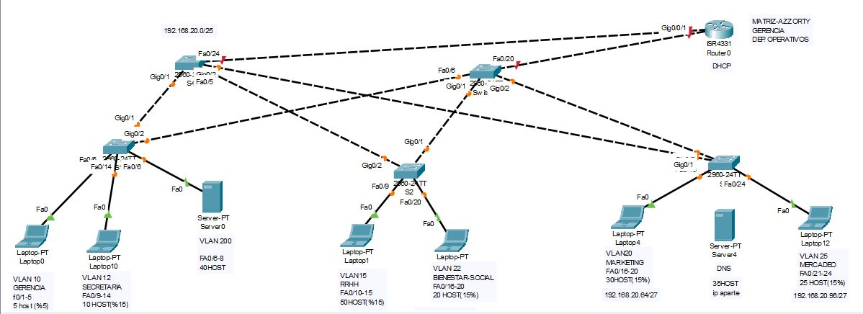

Ip original

192.168.20.0/25

50 host

2^6-2=62

192.168.20.0/26

255.255.255.11

2^6=64

.192

40 host

2^6-2=30

192.168.20.64/26

255.255.255.11

2^6=64

.192

35 host

2^6-2=62

192.168.20.128/26

255.255.255.11

2^6=64

.192

30 host

2^5-2=30

192.168.20.192/27

255.255.255.111

2^5=32

.224

25 host

2^5-2=30

192.168.20.227/27

255.255.255.111

2^5=32

.224

20 host

2^5-2=30

192.168.21.3/27

255.255.255.111

2^5=32

.224

10 host

2^4-2=14

192.168.21.35/28

255.255.255.1111

2^4=16

.240

5 host

2^3-2=6

192.168.21.51/29

255.255.255.11111

2^3=8

.248